

# Email templates

## For friends and family

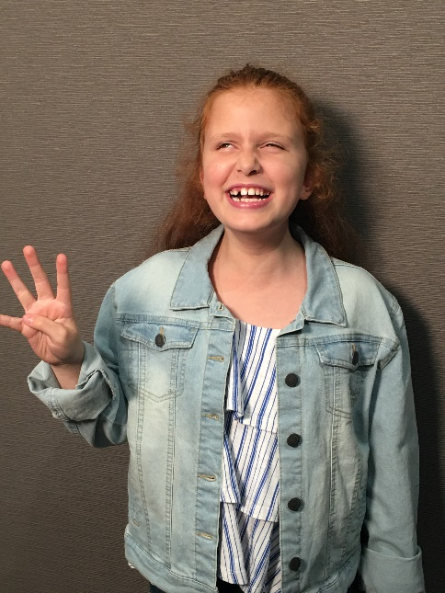Take a photo of yourself holding up 4 fingers in our campaign sign, and post a message with a link to the campaign, like this:

***Text:***

Hello everyone,

I’m making Christmas 4x Brighter this year for kids who are blind or have low vision! Join me by signing up now, and get ready to watch every dollar raised have **4x the impact** for Vision Australia’s children’s services.

**Head to CAROLSBYCANDLELIGHT.COM.AU/BRIGHTER.**

This is important to me because [write your answer here].

That’s why I’m asking you to join me right now and being a part of this campaign for Christmas. Thank you in advance for your support.

## For your workplace

***Message to your manager or HR representative:***

Hello,

I would like to suggest a new campaign that we can support as an organization.

I’ve signed up to make Christmas 4x Brighter this year for kids who are blind or have low vision. Every dollar that is raised through the 4x Brighter Matching Appeal will have 4x the impact thanks to the generous donations of the Vision Australia Community, and this is an opportunity that is too good to miss.

As an organization, we can make a huge impact through this campaign, and that’s why we should:

1. **Make a corporate donation now**, which will inspire others to give.
2. **Sign up a staff team** using the resources available, so that staff can compete against others to raise the most money before Christmas.
3. **Dollar-match what our staff raise**, and turn the 4x matching into 8x the impact.

This is important to me because [write your answer here].

That’s why I’m asking you to join me right now and being a part of this campaign for Christmas. Thank you in advance for your support.